There is an authentication system that works with authentication tokens. For each session, the user will receive a new authentication token that will expire timeToLive seconds after the currentTime. If the token is renewed, the expiry time will be **extended** to expire timeToLive seconds after the (potentially different) currentTime.

Implement the AuthenticationManager class:

* AuthenticationManager(int timeToLive) constructs the AuthenticationManager and sets the timeToLive.
* generate(string tokenId, int currentTime) generates a new token with the given tokenId at the given currentTime in seconds.
* renew(string tokenId, int currentTime) renews the **unexpired** token with the given tokenId at the given currentTime in seconds. If there are no unexpired tokens with the given tokenId, the request is ignored, and nothing happens.
* countUnexpiredTokens(int currentTime) returns the number of **unexpired** tokens at the given currentTime.

Note that if a token expires at time t, and another action happens on time t (renew or countUnexpiredTokens), the expiration takes place **before** the other actions.

**Example 1:**

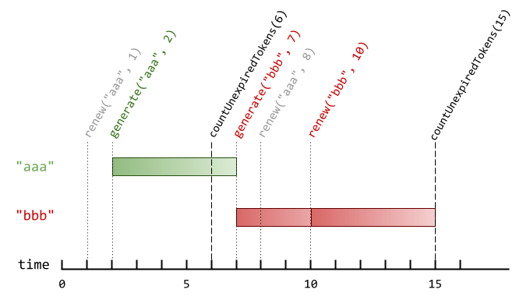

**Input**

["AuthenticationManager", "renew", "generate", "countUnexpiredTokens", "generate", "renew", "renew", "countUnexpiredTokens"]

[[5], ["aaa", 1], ["aaa", 2], [6], ["bbb", 7], ["aaa", 8], ["bbb", 10], [15]]

**Output**

[null, null, null, 1, null, null, null, 0]

**Explanation**

AuthenticationManager authenticationManager = new AuthenticationManager(5); // Constructs the AuthenticationManager with timeToLive = 5 seconds.

authenticationManager.renew("aaa", 1); // No token exists with tokenId "aaa" at time 1, so nothing happens.

authenticationManager.generate("aaa", 2); // Generates a new token with tokenId "aaa" at time 2.

authenticationManager.countUnexpiredTokens(6); // The token with tokenId "aaa" is the only unexpired one at time 6, so return 1.

authenticationManager.generate("bbb", 7); // Generates a new token with tokenId "bbb" at time 7.

authenticationManager.renew("aaa", 8); // The token with tokenId "aaa" expired at time 7, and 8 >= 7, so at time 8 the renew request is ignored, and nothing happens.

authenticationManager.renew("bbb", 10); // The token with tokenId "bbb" is unexpired at time 10, so the renew request is fulfilled and now the token will expire at time 15.

authenticationManager.countUnexpiredTokens(15); // The token with tokenId "bbb" expires at time 15, and the token with tokenId "aaa" expired at time 7, so currently no token is unexpired, so return 0.

**Constraints:**

* 1 <= timeToLive <= 108
* 1 <= currentTime <= 108
* 1 <= tokenId.length <= 5
* tokenId consists only of lowercase letters.
* All calls to generate will contain unique values of tokenId.
* The values of currentTime across all the function calls will be **strictly increasing**.
* At most 2000 calls will be made to all functions combined.